Secure Banking Console App

Problem Statement
In banks, customers need secure systems to manage their accounts.
Manual banking takes time, increases human error, and is less secure.
This project solves the problem by creating a console banking app where users can:
- Create an account
- Log in securely
- Check balance
- Transfer money
- Pay bills
- Auto-logout after inactivity
The goal is to provide a simple and secure system for learning basic banking operations.

Main Functionalities

✔ User Registration
- Name validation (alphabets only)
- CNIC validation (13 digits only)
- Same CNIC number validation
- Account number validation (8 or 10 digits)
- Same number validation
- PIN confirmation
- Initial balance added automatically

✔ Login System
- Login with last four account number digits + PIN

✔ View Balance
- Display the user current balance

✔ Transfer Money
- Sends money from one account to another
- Updates file storage

✔ Pay Bills
- Supports Water Bill
- Supports Gas Bill

✔ Auto Logout
User automatically logs out if inactive for 1 minute.

Special Features, Assumptions, and Limitations

⭐ Special Features
- Input validation (CNIC, PIN, digits only)
- Security checks
- Data stored in text file
- Simple and easy console UI

🔎 Assumptions
- One user performs operations at a time
- File writing and reading work correctly
- Valid numeric values are entered

⚠ Limitations
- No graphical interface
- No encryption of stored data
- Multi-user login not supported yet
- No database (only text file storage)

Conclusion
This project helped me understand:
- File handling
- Functions
- Validation
- Basic security logic
- Real-world banking concepts

Output
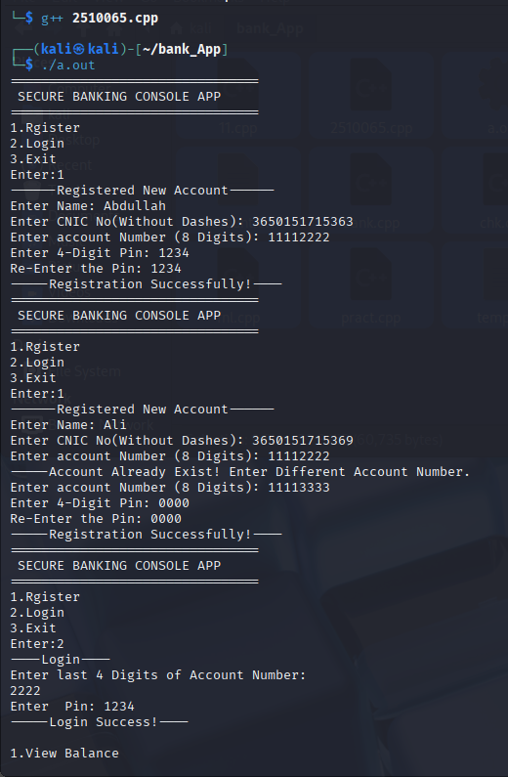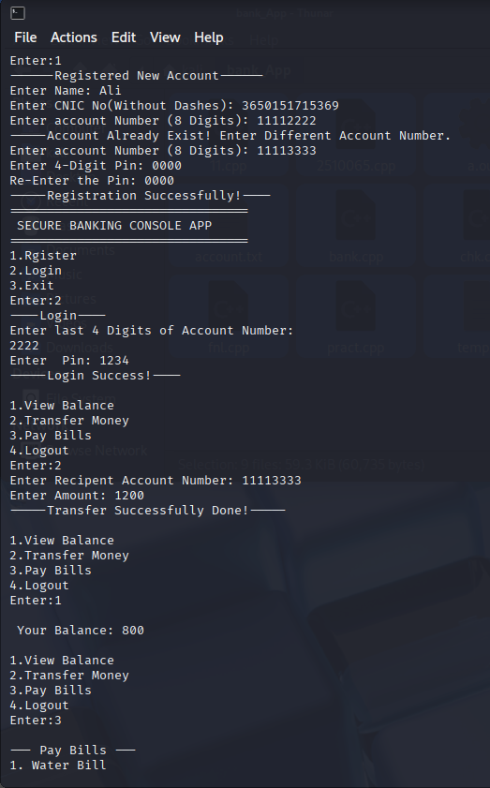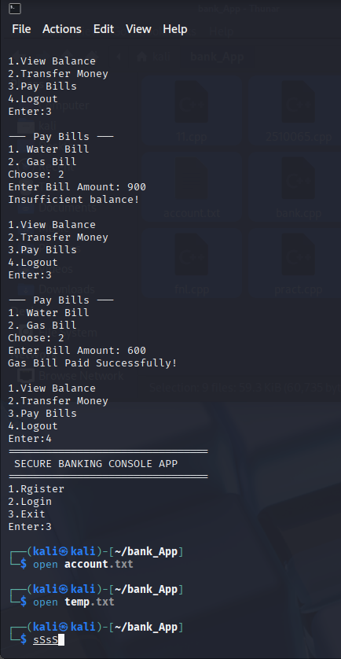
Text file

